Travis Moore

GAT261: Section A — Spring 2017

Professor: Richard Rowan

**­**

HUD Research &

Project Proposal

HUD Research

Star Wars: X-Wing

Summary

*X-Wing* is a space combat games based on the *Star Wars* franchise that was originally released for DOS in 1993. The gameplay of *X-Wing* simulates the fictional experience of starfighter flight and combat while remaining faithful to the movies that they are based upon. While this game has a limited third-person camera mode, it is primarily meant to be played from a first-person cockpit view with a HUD designed to give the player the experience of being a *Star Wars* pilot.

HUD Features

* *X-Wing* uses 2D graphics as a camera overlay to simulate the experience of being in the cockpit of all the different starfighters. The HUD displays the player’s weapons, shields, throttle, energy management, and a simple front and back radar.

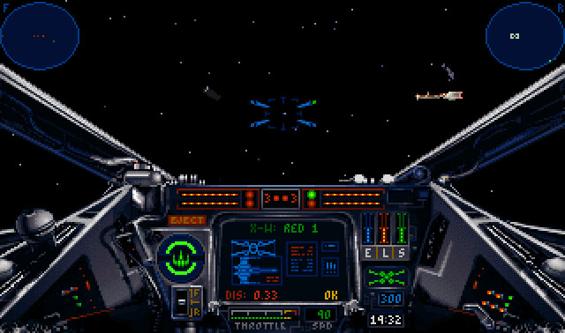

X-Wing’s HUD displays information to the player as if they were actually in the cockpit of an X-Wing

* The reticle and the center portion of the HUD are used for displaying weapons information. The reticle and weapons panel show which cannon is active by displaying a green dot. If the reticle goes dark blue, or the panel is no longer red, then there is no weapon energy.

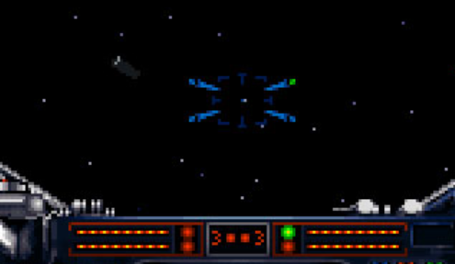

*Currently the upper-right cannon is active, and weapon energy is at maximum charge*

* While *X-Wing* is primarily about space flight and combat, an equally important aspect of the gameplay involves managing the starfighter’s energy levels between the engines (E), lasers (L), and shields (S). Depending on energy allocation, the engines, lasers, and shields will either deplete, recharge, or remain at their current levels.

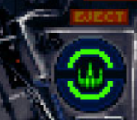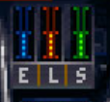

The ship’s shields are at an equal balance of 2 (1 forward & 1 backward shield) out of 4 layers possible.

* The throttle is displayed as a gauge in order to visually show the percentage of energy allocated to the speed of the ship, as well as a number to indicate the current speed value. The gauge shows a green, yellow, and red color change for speed, but it means nothing.

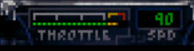

The throttle is currently almost at its maximum speed

* The largest element of the HUD is used as an informational/targeting computer to show the call sign, ship type, distance from, and status of the currently targeted starfighter. This targeting computer can also be toggled to display the positioning of a targeted starfighter either in front of or behind the player.

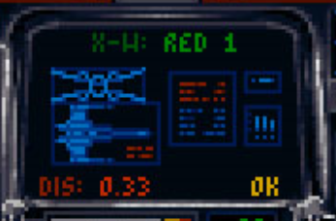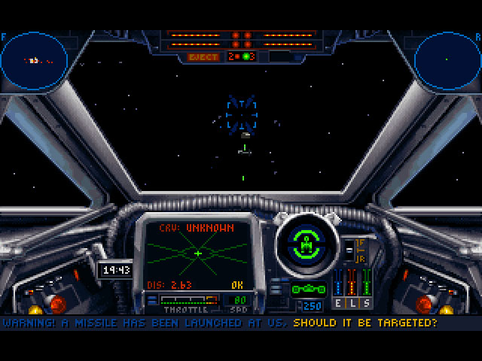

Information displayed in the left image is useful for the recon missions in the game. The targeting computer for the Y-Wing on the right image has been toggled to the targeting mode

Key Takeaways

* The bulk of the camera is covered by the cockpit art, which can make certain starfighters more difficult to pilot because you see less. For example, in the Y-Wing, the cockpit art takes up more screen space than the X-Wing, making it a less-effective vehicle for combat and seeing what is directly in front of you. While this design decision can lend itself to being more aesthetically accurate, this might break immersion when combat difficult from lack of sight becomes a problem.
* The reticle is the most centrally located HUD element, followed by the informational/targeting computer. Considering the game is about space combat, this makes sense. However, the color choices for the reticle are both dark and light blue, which can be easily lost on a black background.
* Color consistency is for the most part spot on, with lasers being matched to red, shield being green, and throttle being blue. However, the reticle is also blue, and green is used to indicate the active laser cannon, which can create some confusion.
* Gauges are used to display percentage quantities over the use of numbers. The energy management system shows energy usage in 0%, 25%, 50%, 75%, and 100% quantities, which is not a problem to make out. The throttle gauge can vary by a lot, but there is a number for displaying the current speed. Laser energy is not listed as a number, but instead as a series of horizontal dashes. This can potentially be a problem for calculating how many shots are left.
* *X-Wing*’s HUD seems like a great example of art taking a priority over ease-of-use. The HUD seems like it is taking up two-thirds of the screen space, leaving little for the player to see. Colors are not as consistently used as they could be, which can make the HUD difficult to understand without the player having to memorize arbitrary rules.

Elite: Dangerous

Summary

*Elite: Dangerous* is a space adventure, trading, and combat simulation game that has the player piloting a spaceship in a 1:1 scale open world galaxy. *Elite: Dangerous* is renowned for being a highly immersive and gripping “flying a spaceship” experience, whether you are playing the game traditionally with a mouse and keyboard or in virtual reality with a flight joystick. Like in *X-Wing*, *Elite: Dangerous* is played in a first-person view with an emphasis on placing the player in the cockpit of a space ship. There is no third-person camera mode, other than the debug ship viewing camera.

HUD Features

* The default HUD settings in *Elite: Dangerous* is very open, and very mono-chromatic. Unlike in *X-Wing* the viewing space through the forward viewport takes up the majority of the screen, allowing for a much easier piloting experience. HUD information can be found all over the screen, but is grouped in a way that mostly makes sense.

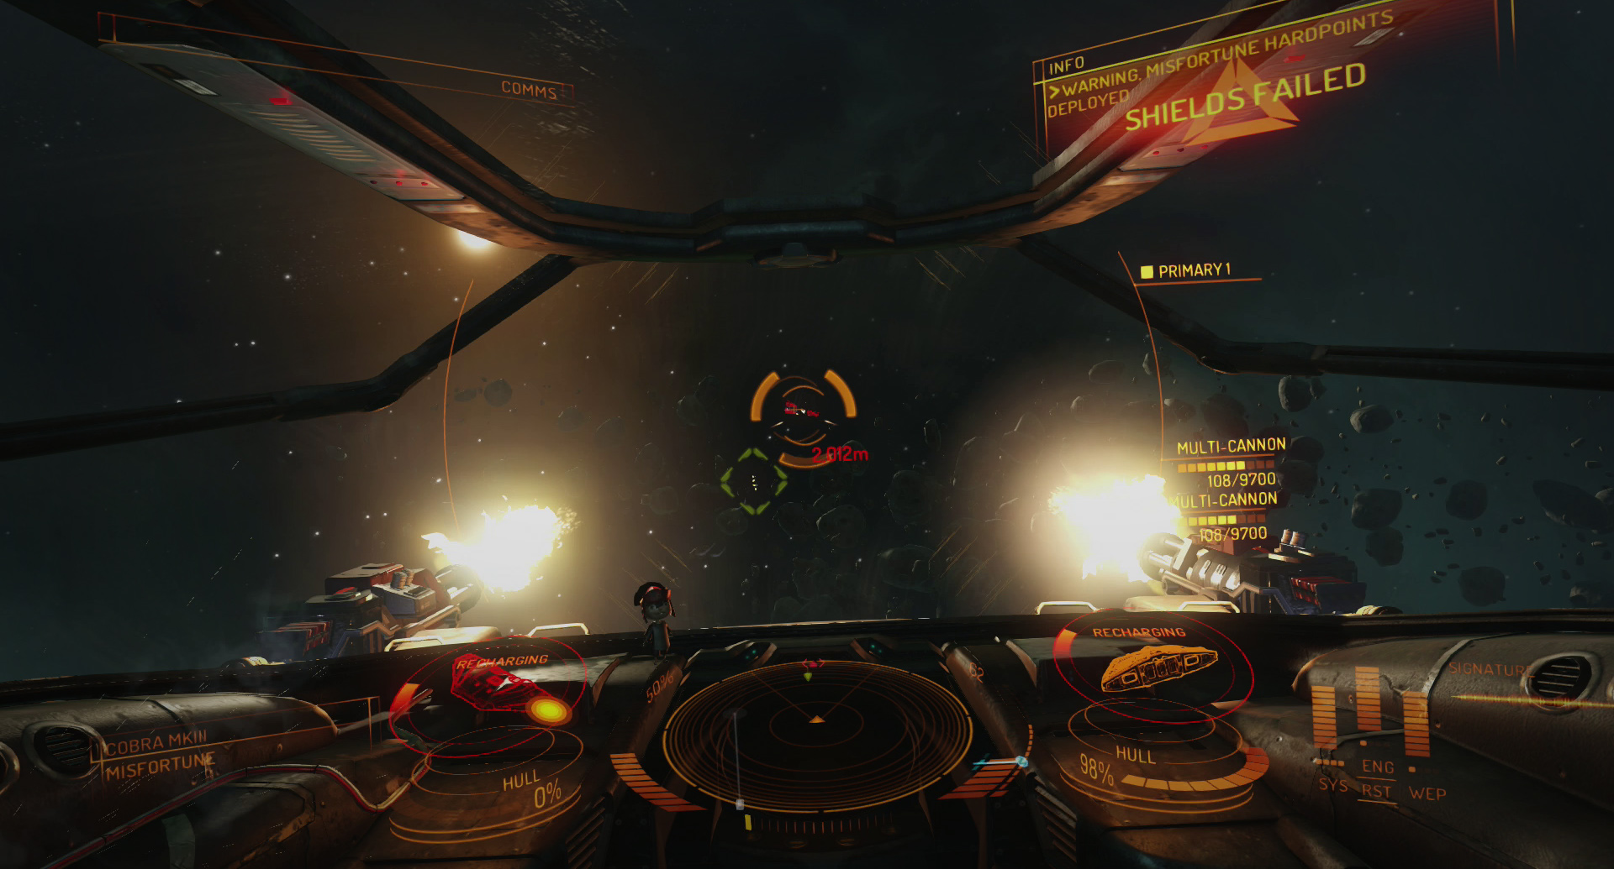

The HUD information is mostly transparent for a 3D/holographic feel that allows the player to see through

* There is an enormous amount of information that can be on the screen at any point in time, but thankfully the information is grouped together in logical chunks. A breakdown of the positioning of elements within the HUD has communications and information on the upper corners of the screen, the targeted ship information on the lower left of the screen, the player’s ship information on the lower right of the screen, and navigation on the bottom center of the screen.

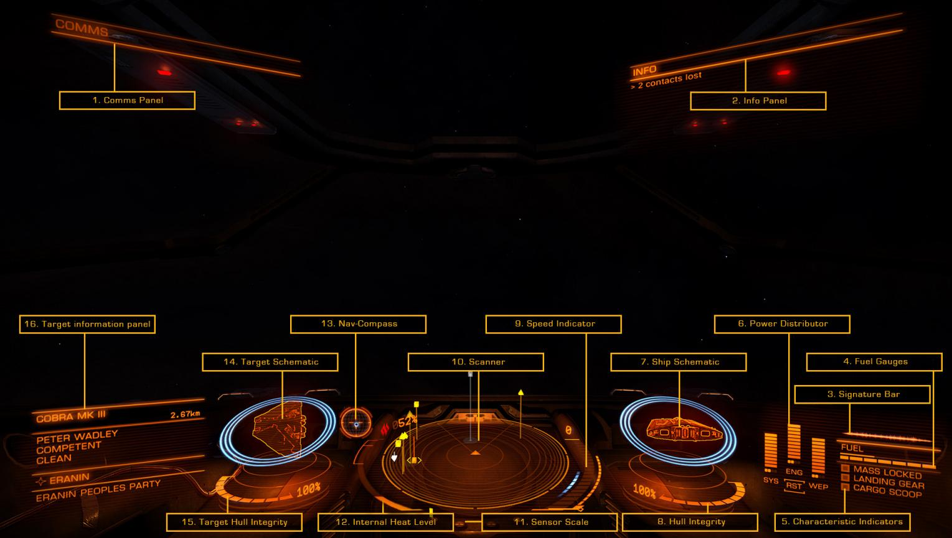

Despite the logical groupings of information on the screen, the monochromatic nature of all information can make everything look the same upon first glance.

* The center portion of the HUD is reserved for the targeting reticle and weapons status. Red triangles appear around the targeted ship to help indicate its rotation and direction in space. Energy levels are displayed using horizontal bar chunks for visual representation of percentages and are backed up with number ratios, as well.

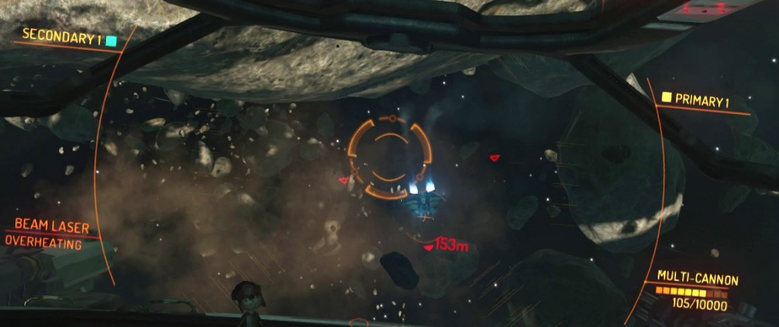

When a submenu option is selected from a list of options a reserved color and shape combination is used to designate that option as selected.

Key Takeaways

* While more stylistically mature compared to *X-Wing*, *Elite: Dangerous*’ monochromatic delivery of information can make things difficult to distinguish on the HUD.
* Clever use of the alpha channel can make intrusive HUD elements appear less so, and can be used to give emphasis in moments of crisis for something that the player needs to be aware of right at that moment.
* Despite there being a lot of information on the screen, the HUD breathes better because the cockpit feels more open.
* All gauges are backed up with text and numbers. Gauges are split into ticks/chunks and are never solid bars. There is no use of iconography present in the HUD.
* Clear and easy to read typography that is always all caps. All caps may or may not be a bad thing, depending on the font. In the case of *Elite: Dangerous* I believe they choose a good font that is actually using proper small caps and not scaling down normal all caps.
* 3D model representations of ships look amazing and can help reinforce the orientation of a ship in an easy to understand way. The addition of the three small triangles on a targeted ship that rotates appropriately with the ship is amazing at helping a pilot understand the motions of a ship at a distance.
* The logical grouping of same or alike HUD elements helps train the player where to look for similar information.
* Consider fading HUD information in and out as needed. Even though all the information is handled well, it can still be overwhelming to keep it all on screen. For example, the combat reticle and weapon information may not always be necessary and should be toggled on/off when needed.

Redout

Summary

*Redout* is a futuristic high-speed racing game that have the player piloting incredibly fast anti-gravity ships on race courses across various planets. In addition to being a third-person camera based game, *Redout* has a HUD focused on racing, which is information that my HUD will need to display for the player.

HUD Features

* With an emphasis on racing, *Redout* uses the top corners to display lap and time-based information, while the lower half of the HUD displays ship related information to the player.

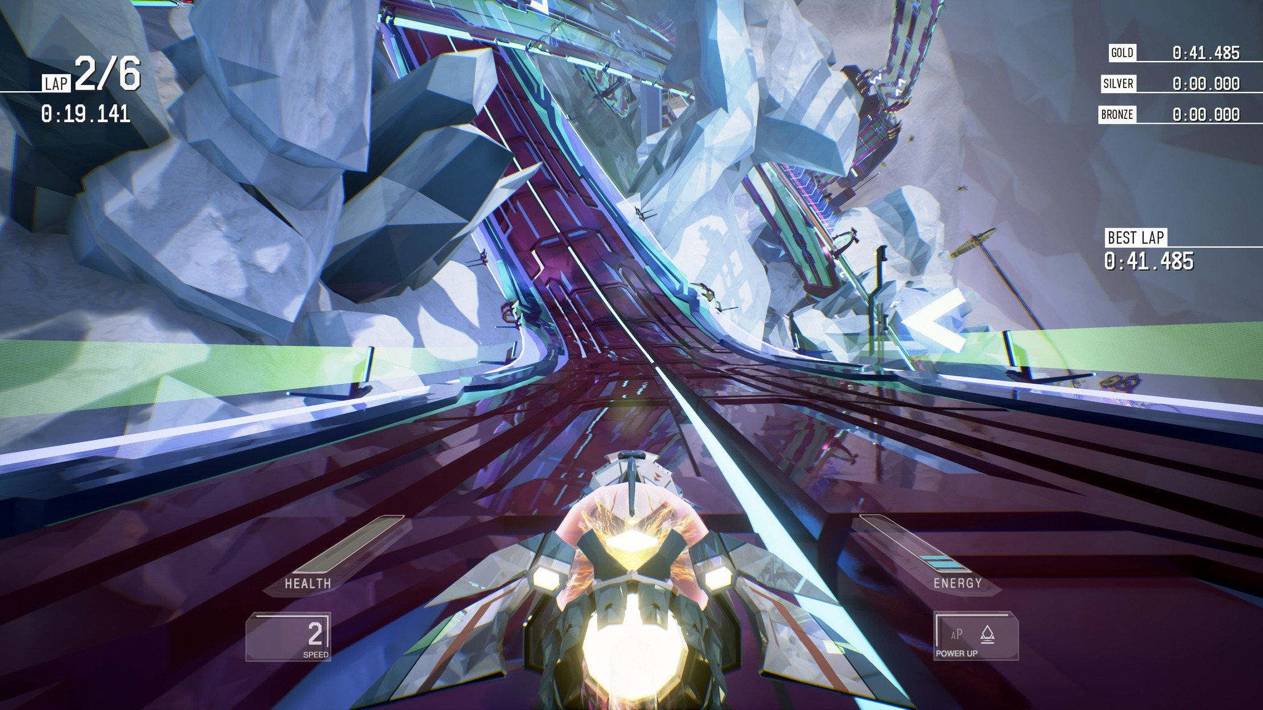

An interesting mix of standard, front-facing HUD information and rotated energy bars provide a non-traditional HUD that is visually appealing.

* An alternative version of the HUD is displayed depending on how far zoomed in the third-person camera is on the ship. This mode flattens out the health and energy bars to make them easier to read and centrally located the speedometer of the ship.

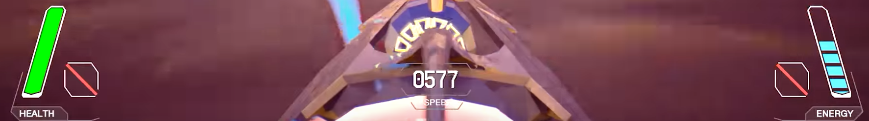

While the health and energy portions of the HUD are easier to read, the centralized speed of the ship can potentially get lost on the white sections of the ship model

Key Takeaways

* Minimal HUDs are clean and easy to look at. The alpha channel is used to help the non-vital aspect of the HUD (containers and lines) fade into the scene instead of standout unnecessarily.
* White is mostly reserved for HUD information, while colors are used as an accent for the type of information being displayed. Typography is again all caps (standard, not small-caps).
* Bars are used to graphically display information, but are not supported with their actual values in numbers. This could potentially cause problems with players who would rather know exact values.
* Parts of the HUD, like checkpoint time information, are flashed briefly in the upper central part of the screen before fading out. This is temporary useful information that does not need to exist all the time.
* The rotated HUD elements are visually interesting but definitely difficult to read, especially when going fast, as they zoom into the scene with the ship.
* Overlapping HUD information, like the speedometer, on top of the ship model is bad.

HUD ­Project Proposal

HUD Features

*Super Space Race* is a space flight/combat racing simulation and will need the following HUD features to be designed with scripted functionality:

* Time Tracker (counting up or down) that counts the minutes/seconds/milliseconds.
* Energy Gauge that tracks the shield/throttle/weapons energy of the ship
* Shield bar that displays the current shield level
* Throttle gauge that displays the current speed
* Weapons bar displays the amount of shots left
* Targeting/Aiming Reticle
* Limited cockpit art
* Optional navigation bar that displays the direction of the next checkpoint is relative to the ship.

Multiple HUDs

I would like to challenge myself to create both a first-person cockpit view and a third-person ship view HUD. I realize this means double the design work, but I think it would be interesting and help showcase my abilities as a UI designer.

Camera Transition

A zoom in/out camera transition between both camera views that also animates different HUD designs on/off the screen.

Theme & Consistency

The theme of the HUD will have a minimal and sci-fi look to it that matches the current look and feel of *Super Space Race*.Consistency is key in establishing patterns for ease of use for understanding and recognizing and navigating the HUD effectively. I’ll be establishing a style with a set font and the color white will utilized for all HUD elements with alpha channel transparency as needed. I will reserve certain colors to represent the throttle, shields, and weapons. Hierarchy in information will be established through size relationships and spacing.

Wireframe: Cockpit View

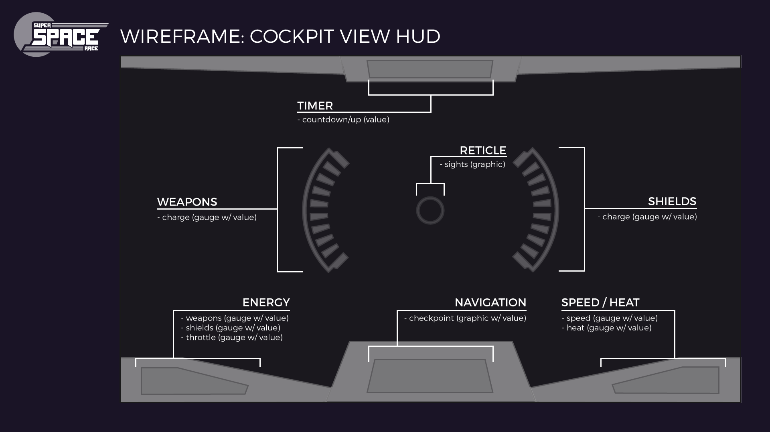

Wireframe: Ship View

